Practical - 1
Practical Title: Project Initiation, Requirement Analysis, Sitemap, Wireframe, and GitHub Setup

Problem Definition: Initiate the semester-long StudentHub portal by identifying the problem scope, user roles, key modules, navigation flow, and minimum 10 pages. Create a sitemap, low-fidelity wireframe, project folder structure, README file, and GitHub repository.

Theory

What is URL and parts of URL?
Answer:
A URL (Uniform Resource Locator) is a unique address used to locate and access resources on the internet.
- Identifies the location of a resource online.
- Specifies the protocol (e.g., HTTP or HTTPS).
- Includes the domain name or IP address.
- May contain a path to a specific resource.
- Used to access web pages, files, images, and other online resources.
Parts of URL
scheme, subdomain, domain, top-level domain, port, path, query string, and fragment
website used:-
https://www.geeksforgeeks.org/computer-networks/components-of-a-url/

How does HTML file process in web browser?
Answer:
When you open an HTML file, the browser follows a quick 5-step process to put it on your screen:
- Parse HTML: It reads your code and builds a structural map of the content (the DOM).
- Parse CSS: It reads your stylesheets to understand the design rules (the CSSOM).
- Render Tree: It combines the content and design into one tree, dropping anything that is meant to be hidden.
- Layout: It calculates the exact math for where every element should sit based on your specific screen size.
- Paint: It draws the actual pixels onto the screen so you can see the web page.

3. How will page navigation flow managed among all HTML pages?
Answer:
Page navigation is handled in one of two ways, depending on how the website was built:
- Traditional (Multi-Page): The browser manages it. When you click a link, the browser requests a completely new HTML file from the server, clears the screen, and reloads the entire page from scratch.
- Modern (Single-Page): JavaScript manages it. When you click a link, JavaScript prevents the page from reloading. Instead, it quietly fetches only the new data it needs and updates just that specific part of your current screen, making the transition feel instant.

4. How will GitHub commits be maintained after each practical?
Answer:
Here is the quick workflow to maintain your repository after every practical session:
1.Stage Changes:
Tell Git which files you want to save. Use git add . to include all modified files in your current folder.
2.Commit Changes:
Save a snapshot of your code with a clear message explaining what you did. Use git commit -m "feat: completed practical 1".
3.Push to GitHub:
Upload your local commits to your remote repository so they are backed up. Use git push origin main.

Evidence of Work (Screenshots)

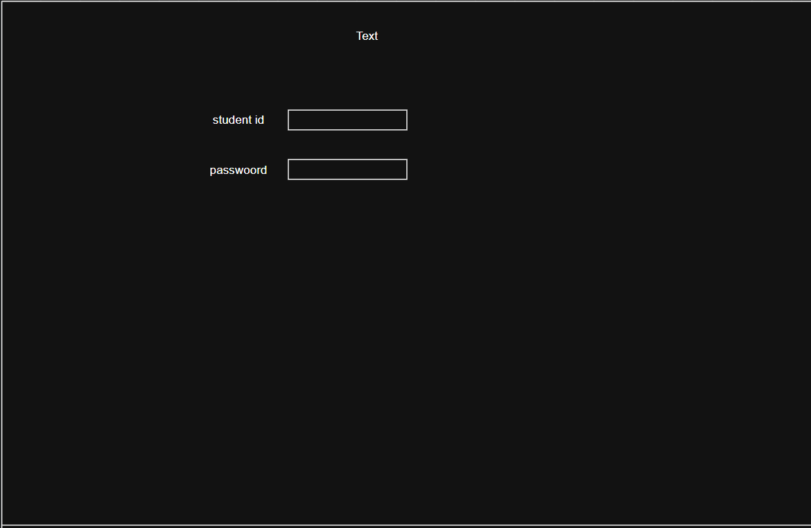

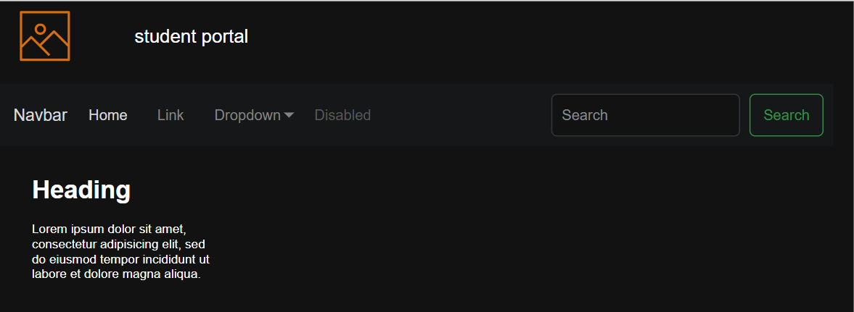

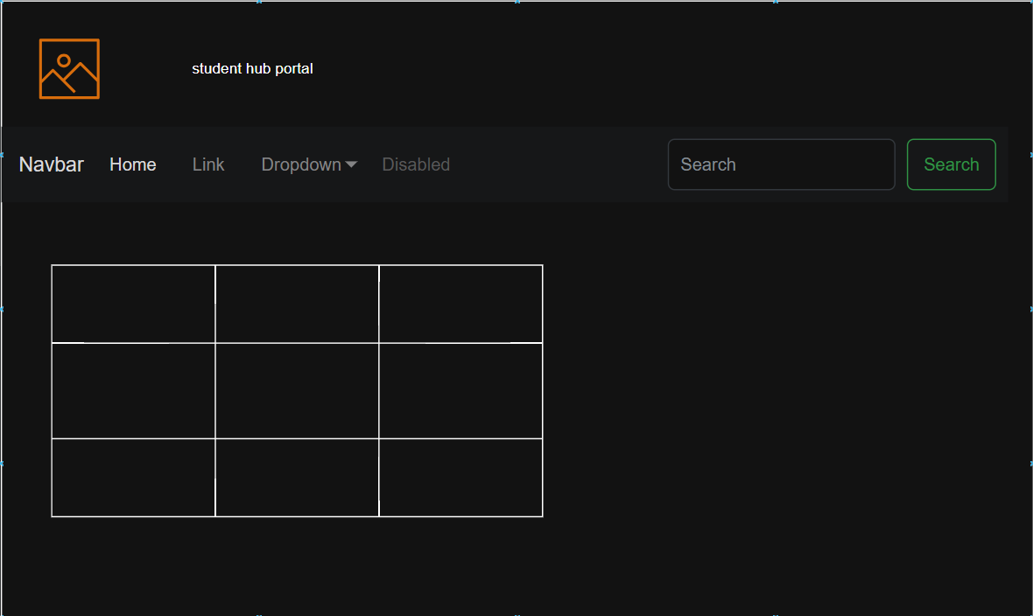

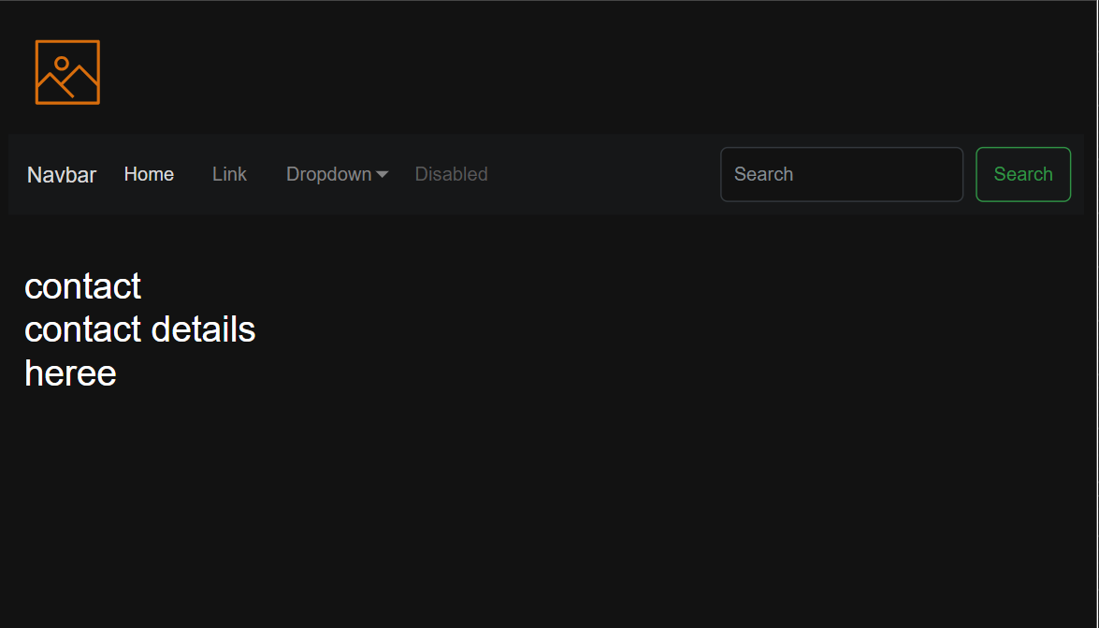

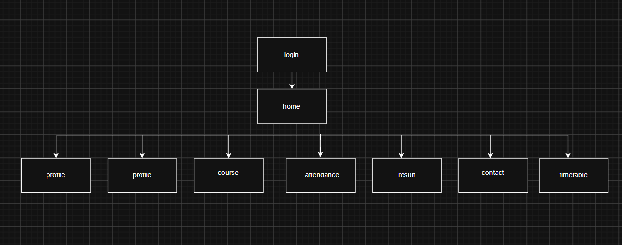

GitHub Repository Link:
https://github.com/RajMonani/Student-Portal-Hub

Challenges Faced:
First it was difficult and hard to understand directly using html code

Learning Outcomes:
After learning from figma it becomes comparatively easy in html code

Faculty Remarks:

